7.44: Work done by friction against the crate brings it to a halt:
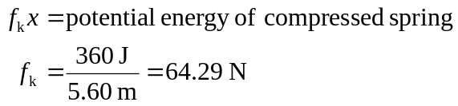
The friction force working over a 2.00-m distance does work The kinetic energy of the crate at this point is thus 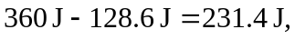 and its speed is found from
